Coffee Conversations with Legislators: A WiAHC Advocacy Program

Program Overview:

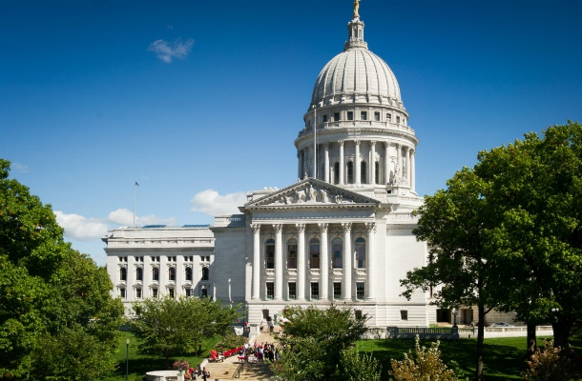
Coffee Conversations with Legislators is a WiAHC advocacy program to help connect members with their local legislators. Under the program, the WiAHC Government Affairs Team will set-up in-district meetings between WiAHC members and state lawmakers who represent them in the Legislature. These meetings, which can be located at your facility or a local coffee shop provides a tremendous opportunity for WiAHC members to build or strengthen their relationships with local legislators and to educate them on the importance of home health care and on policy issues important to home health care professionals and their patients.

Program Objective:

To encourage WiAHC members to meet face-to-face with their local legislators, strengthen their relationship with them, and ultimately to ask them for their support for issues important to WiAHC and home health care in Wisconsin. Building relationships with lawmakers is the most important aspect of advocacy and in-person meetings are the most effective means of making those personal connections. WiAHC Coffee Conversations with Legislators will allow members to directly communicate with their legislators and provide an opportunity to work more closely with them to draft, introduce, and ultimately pass into law legislation of importance to the WiAHC membership.

Program Goals for Members:

- Introduce yourself and home health care to your legislators.

- Educate your legislators on the home health care industry and connect WiAHC legislative issues with decisions that are being made at the State Capitol.

- Make a specific request of your legislators (i.e., support a specific bill; etc.).

- Lay the foundation for an ongoing working relationship with your legislators.

Member Engagement:

Few state legislators are experts on home health care and the policies that impact the industry. However, legislators can and do make decisions that affect home health care, so it is important to provide them access to subject matter experts. As a WiAHC member and a respected leader in your field, you are in a strong position to become a resource for your legislators.

Interested? Next Steps…

If you would like to participate in the Coffee Conversations with Legislators program, please contact the WiAHC office at mwelsh.badgerbay@gmail.com. The WiAHC Government Affairs Team will work with you and your legislators to coordinate the meetings and will provide participating members with full support, including legislator bios, advocacy tips, issue briefings, and supporting documents.

