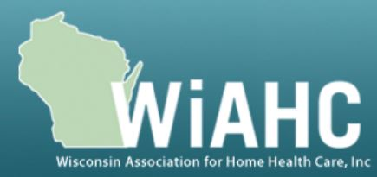

About WiAHC
The Wisconsin Association for Home Health Care (WiAHC) is a membership-based association that represents home health care agencies and their staff. WiAHC helps to support the common interests of its members to promote home health care as a quality, cost-effective health care option in our state.

Home health care agencies provide skilled nursing, occupational therapy, physical therapy, speech therapy, and other medical services to patients receiving post-acute medical care in their homes following discharge from a hospital.

Senate Bill 700 and Assembly Bill 729 bring Wisconsin’s regulations in line with federal regulations by eliminating home health care professional advisory bodies but maintaining governing bodies.
WiAHC Supports Senate Bill 700 and Assembly Bill 729 (As Amended)
Current state administrative rules require each home health agency to establish a professional advisory body, which is required to review and submit recommendations to the governing body regarding various operational matters each year. However, in 2017, federal regulations eliminated professional advisory committees and instead created an ongoing quality assessment and performance improvement (QAPI) program (Title 42, Part 484.65).

QAPI is an ongoing program for quality improvement and patient safety that requires home health agencies’ performance improvement efforts to address priorities for improved quality of care and patient safety and are evaluated for effectiveness.

A Home Health agency’s governing body is ultimately responsible for ensuring that the QAPI program is operated properly. An additional professional advisory body is no longer needed in state administrative rules now that the federal government has eliminated professional advisory committees and required home health agencies to implement QAPI programs, which prioritizes quality of care and patient safety.

Bill authors Senator Ballweg and Representative Rozar introduced identical amendments to modify both bills so that the bills only eliminate professional advisory bodies but maintain governing bodies.

Information on Home Health Care Agency Governing Bodies
According to DHS 133.05(1) in state administrative rules, each home health agency is required to have a governing body, which must do the following:
- Adopt governing policies in the form of by−laws, charter, written policies or other official means.
- Adopt a statement detailing the services to be provided.
- Oversee the management of the home health agency.
- Appoint an administrator.
- Provide for a qualified substitute administrator to act in absence of the administrator.

Contact Information
Please contact Tim Hoven at (414) 305-2011 or tim@hovenconsulting.com or Nathan Butzlaff at (608) 310-8833 or nathan@hovenconsulting.com.

